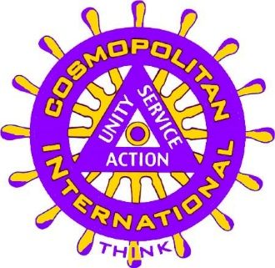
2018 International Convention
Kansas City, Missouri

Schedule of Activities

Wednesday, July 25, 2018
1:15 p.m. | Optional Royals Baseball Game | Meet in lobby at 12 p.m.
3 to 5 p.m. | Registration | Grand ABC Foyer
6:00 to 11 p.m. | Hospitality Suite with Complimentary Pizza | Royal Ballroom
6:30 p.m. | PIP Dinner | Meet in lobby at 6 p.m.

Thursday, July 26, 2018
7 a.m. to 5 p.m. | Registration | Grand ABC Foyer
7 to 8 a.m. | First Timer Orientation | Grand A
8:15 to 9:45 a.m. | CDF Board Meeting | Monarch
10 a.m. to noon | CI Board Meeting | Monarch
12:30 to 2:00 p.m. | Opening Ceremonies/Welcome Luncheon | Grand EFG
2:30 to 5:30 p.m. | Explore KC/Steamboat Arabia Museum Tour | Meet in lobby at 2:30 p.m.
6:30 p.m. | Cosmos Got Talent Dinner and Show | Grand EFG
6 to 11 p.m. | Hospitality Suite | Royal Ballroom

Friday, July 27, 2018
8 to 9 a.m. | Registration | Grand ABC Foyer
9 to 11 a.m. | Cosmopolitan Educational Forum | Grand ABC
9 to 11 a.m. | Awards Judging | Boardroom
11:30 a.m. to 1 p.m. | CDF & CFC Luncheon | Grand EFG
1 p.m. to 5 p.m. | Health Fair with Exhibitors | Grand ABC Foyer
5:30 p.m. | Dinner and Harrah’s Casino | Grand EFG (dinner); meet in lobby at 6:45 p.m. to depart for Harrah’s
6 to 11 p.m. | Hospitality Room | Royal Ballroom

Saturday, July 28, 2018
8 to 9 a.m. | Registration | Royal Ballroom
9 to 11 a.m. | Delegates Meeting | Grand ABCD
11:30 a.m. to 1:30 p.m. | Installation Luncheon | Grand EFG
1:45 to 2:45 p.m. | CI Board Meeting | Grand ABCD
3 to 4 p.m. | CDF Board Meeting | Grand ABCD
6 to 7 p.m. | President’s Reception | Grand EFG
7 to 11 p.m. | President’s Awards Banquet | Grand EFG

Sunday, July 29, 2017
8:30 to 10 a.m. | Wrap-Up Breakfast | Grand EFG

Note: Activities and events will take place at Adam’s Mark Hotel and Convention Center unless otherwise noted.

